**SHRI RAMSWAROOP MEMORIAL**

**UNIVERSITY**



MBA 1st year

Business analytics session (2023-24)

Subject – Design Thinking (MMG 2702)

"Designing for IBM's Customers: A MURAL-Assisted Approach”



SUBMITTED TO SUBMITTED BY

MS. DIKSHA PANDIT Avinash Sharma

202310702080014

**ACKNOWLEDGEMENT**

I am highly grateful to the **MISS DIKSHA PANDIT**, IBM FACULTY **SHRI RAMSWAROOP MEMORIAL UNIVERSITY LUCKNOW** for providing this opportunity to carry out the major project work at. The constant guidance and encouragement received from Dr. MUNISH KUMAR TIWARI H.O.D IMCE has been of great help in carrying out the project work and is acknowledged with reverential thanks. I would like to express a deep sense of gratitude and thanks profusely to MISS DIKSHA MA’AM, without her wise counsel and able guidance, it would have been impossible to complete the project in this manner. I express gratitude to other faculty members of Analytics and department of SRMU for their intellectual support throughout the course of this work.

Finally, I am indebted to all whosoever have contributed in this report work.

**Avinash Sharma**

**MBA BA (202310702080014)**

**TABLE OF CONTENT**

**CONTENTS**

**ACKNOWLEDGEMENT**

**ABSTRACT**

**CHAPTER 1**- Introduction

**CHAPTER 2**- Problem definition

**CHAPTER 3**- Empathy map

**CHAPTER 4** - Persona Perspective

**CHAPTER 5** - Video scenario

**CHAPTER 6** - Storyline

**CHAPTER 7**- Storyboard

**CHAPTER 8**- Crafting Hills

**CHAPTER 9**- Priority grid

**The Fall and Rise of the ‘Big Blues’**



**Abstract**

IBM has historically been deeply involved in all aspects of computing, offering a diverse range of products and services including hardware like mainframes and PCs, software solutions, networking services, and financing options. However, despite its broad portfolio, IBM faces significant investment risks. The company must continually identify new growth opportunities to counterbalance any decline or stagnation in its existing businesses. To regain its position as a market leader, IBM must refocus on customer-centric strategies, prioritize efforts to enhance shareholder value, and expand its product and service offerings. By doing so, IBM can potentially mitigate investment risks and reclaim its status as an industry leader. IBM’s problem that were faced because of negligence and the How Might We statements gave way to solve those.

**Introduction**

IBM adopted its current name, it was known as the Computing-Tabulating-Recording Company (CTR). This name was used from its inception in 1911 until 1924 when it changed to International Business Machines Corporation (IBM).IBM entered the computing market with its Automatic Sequence Controlled Calculator in 1944. The Mark I was followed by a series of products in the 1950s that helped establish the future of IBM and the computer industry. In 1952, Thomas Watson, Jr., became the president of IBM. Watson envisioned the future of computers and pushed IBM to meet the challenge. Under his leadership, revenue grew from $900 million to $8 billion. One of Watson's greatest moves for IBM was the unbundling of the components of hardware, services, and software that were previously sold in packages. This move gave birth to the multibillion dollar industry that exists today (Carroll, 1993). Throughout the 1960s and 1970s, IBM introduced many products that helped transform the computer industry. The 1960s saw the introduction of IBM's System/360, which allowed customers to upgrade portions of the computer without having to incur the greater expense of replacing the entire computer.

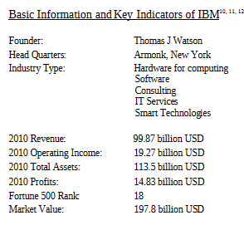

**WHERE IS IBM HEADING IN THE PC MARKET?**

The PC revolutionized the market because it provided each user with a stand? Alone machine. But when PCs are connected to a network, some of the old centralization problems occur. If all users can use a software program that is stored on the network? Server, the necessity for an individual copy of the software for each user is eliminated. IBM's plan is to provide a new technology? The network computer.

The network computer will be an inexpensive replacement for the personal computer in a networked environment; 100,000 of these computers were sold in 1997 (Cook, 1998). Network computers (NCs) will be an interchangeable commodity that will save money for their customers but may also erode the sales of current mainline PC makers, including Compaq. NCs will not be a replacement for the PC, but instead will eliminate the higher expense of purchasing PCs in a work environment when there is not the necessity for every user to have one. Instead, PCs will be reserved for mobile users (laptops) and for personnel that need to run very powerful programs, such as computer? Aided design (CAD).

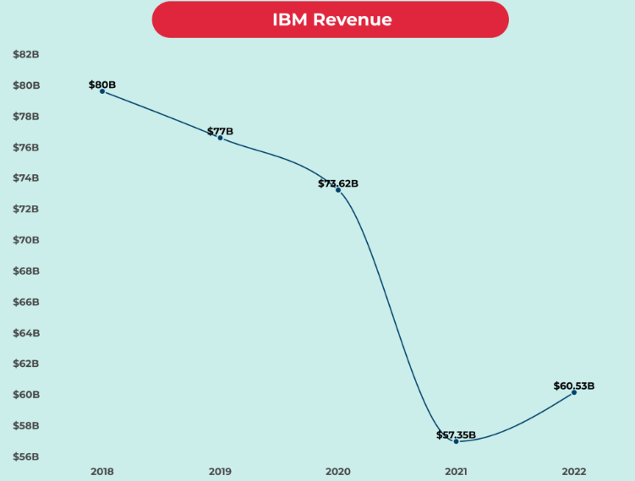

**Reasons for the fall:**

1. IBM developed most components of its PCs in-house, giving it a competitive edge. However, as the industry evolved, this approach became less sustainable and cost-effective, leading IBM to incorporate components from other companies.
2. IBM's decision to incorporate components from other manufacturers and open up its platform contributed to the commoditization of PCs and their parts, leading to increased competition as other companies produced IBM PC-compatible systems at lower costs.
3. IBM's decision to use components from other manufacturers led to cheaper IBM PC-compatible systems and intensified market competition.
4. IBM confronted escalating margin pressures due to declining component expenses and PCs being perceived as more accessible commodities, hampering profits in its PC division.
5. IBM's struggle to innovate in the dynamic PC market hindered competitiveness despite efforts to adapt, limiting technological advancements and meeting consumer needs.

**IBM's Current Focus:**

Following the sale of its PC division, IBM shifted its focus towards areas such as analytics, cloud computing, and mainframe sales. These strategic moves align with IBM's strengths in enterprise solutions and aim to capitalize on emerging technologies and market trends.

**How Might We Statement**

1. How might we optimize IBM's PC component procurement to bolster competitiveness while maintaining cost-effectiveness?
2. How might we leverage strategic partnerships to enhance IBM's PC component supply chain efficiency and reliability?
3. How might we foster innovation within IBM's PC division to develop cutting-edge components and maintain market relevance?
4. How might we streamline IBM's PC production process to mitigate margin pressures and maximize profitability?
5. How might we conduct market research to identify consumer needs and align IBM's PC offerings accordingly?

**EMPATHY MAP**

An empathy map serves as a valuable tool within design thinking and user experience design, aiding teams in gaining deeper insights into their users or customers. It offers a straightforward framework segmented into various aspects of the user's experience, including their thoughts, emotions, observations, and actions.

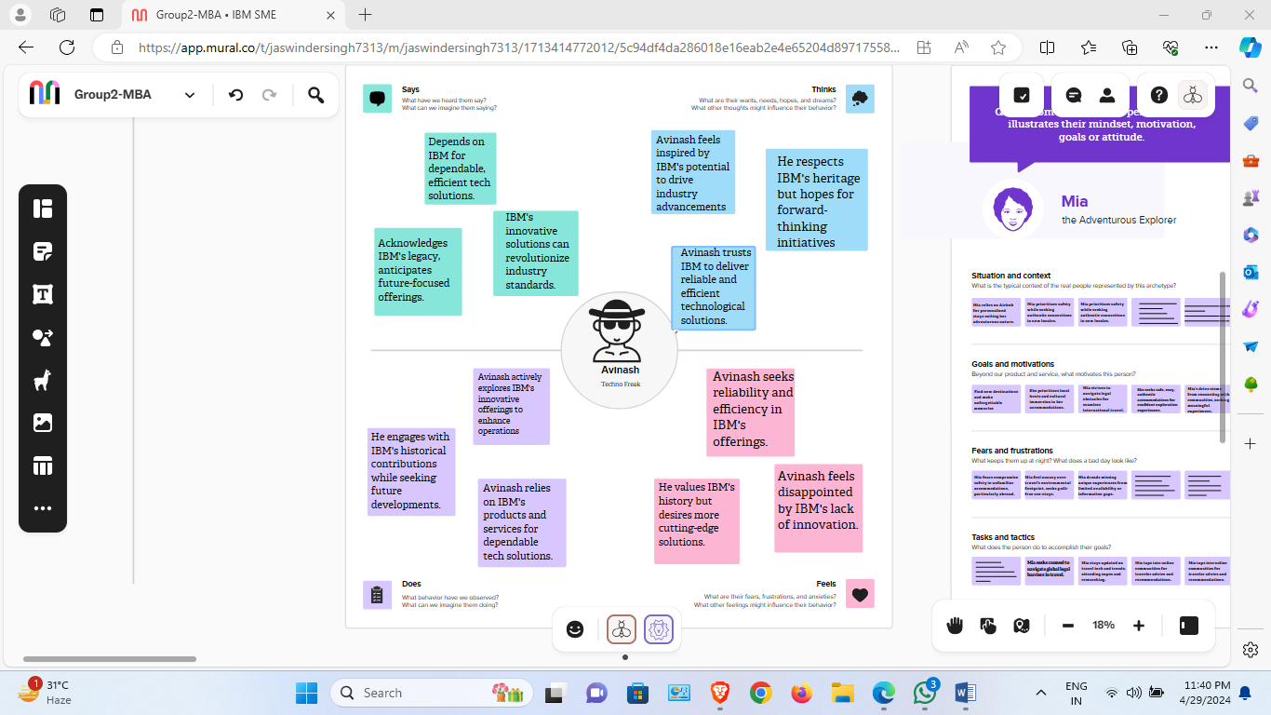

**PERSONA PERSPECTIVE**

Personas are like made-up people who stand for the different kinds of users that could use a product, service, or system. They're created using information from real users and help design teams imagine and get what their target audience wants, aims for, and does.

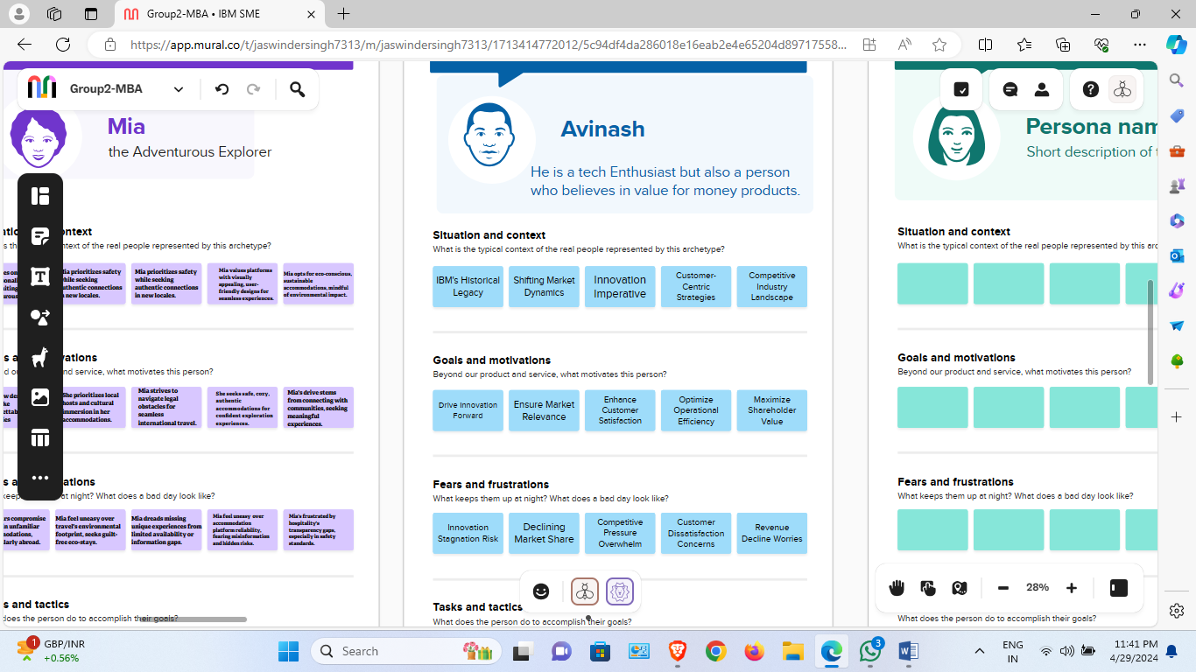

**VIDEO SCENARIO**

Teams can utilize MURAL's digital canvas to craft storyboards outlining a video's events. Each frame depicts crucial moments or scenes. MURAL enables the incorporation of visuals like pictures, icons, and shapes, aiding in illustrating actions and interactions. Additionally, teams can include text notes for context or more details.

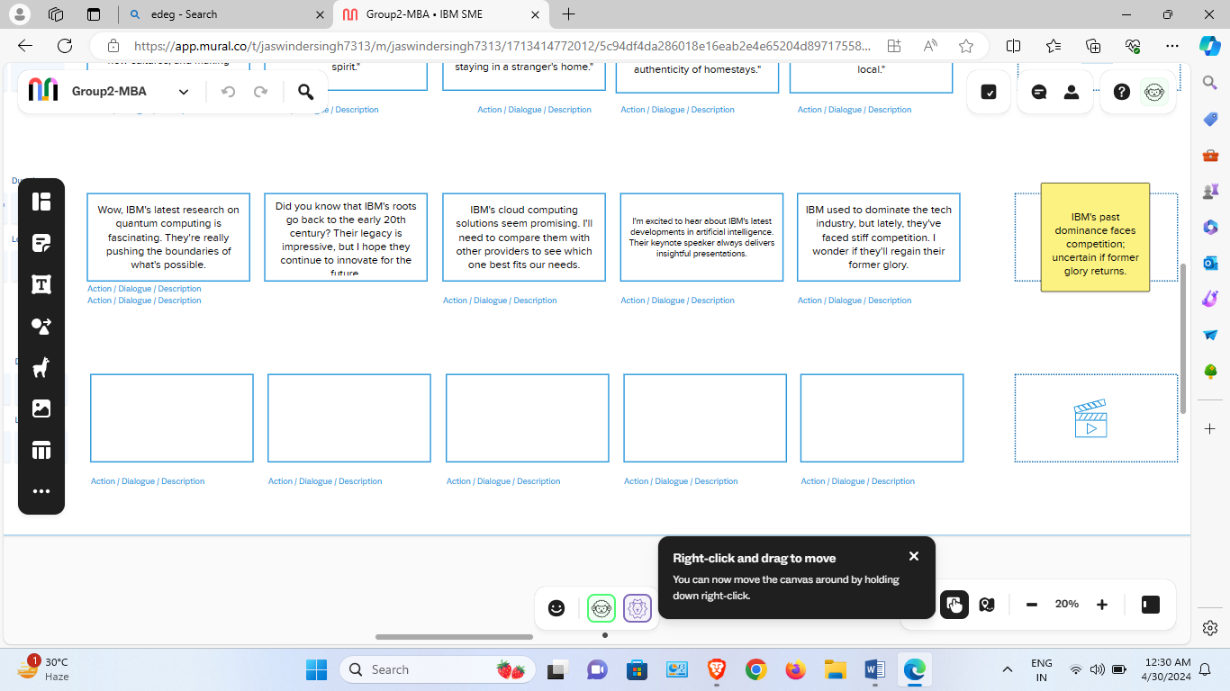



**STORYLINE**

Employing MURAL's digital canvas to visually plot the storyline of a tale, including crafting a timeline, pinpointing major plot moments, and arranging scenes or chapters. Experimenting with interactive storytelling methods in MURAL, like branching narratives or choose-your-own-adventure plots, by developing interactive prototype to assess various story paths and results.

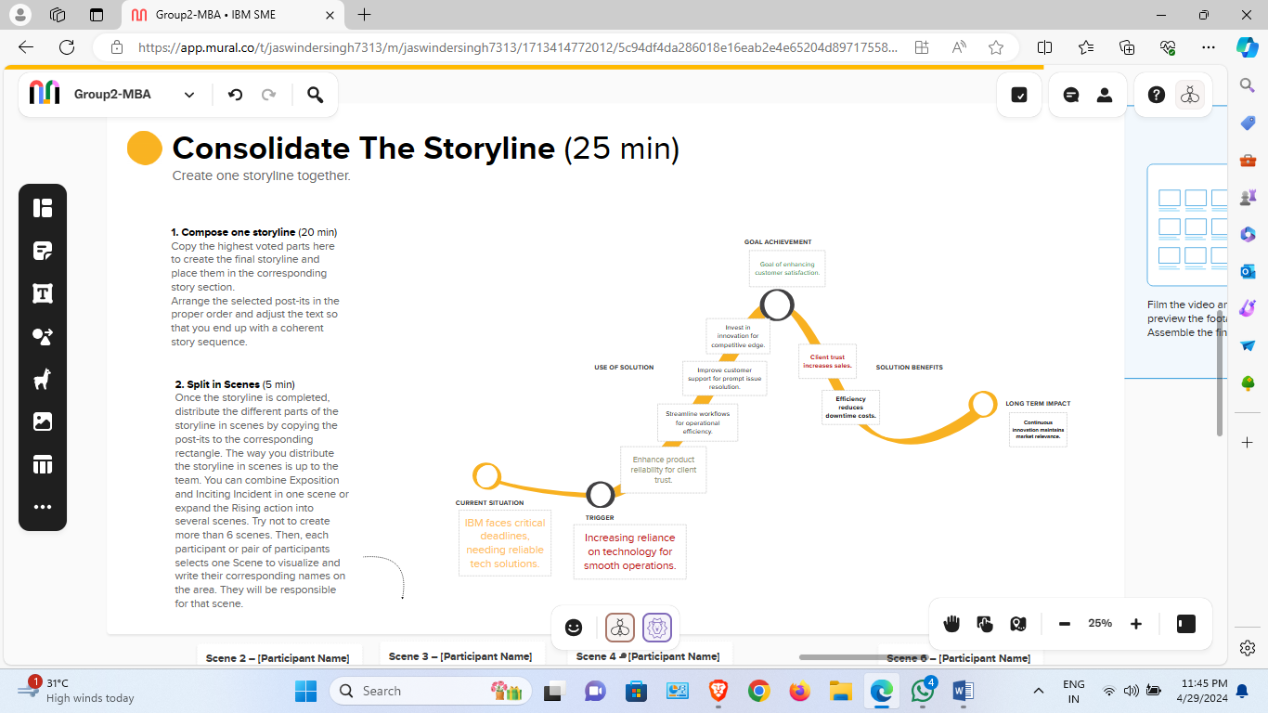



**STORYBOARD**

Crafting a storyboard for a narrative or visual project using MURAL, which may entail sketching scenes, framing shots, and organizing visual elements to steer the storytelling process. Experimenting with interactive storytelling methods within MURAL, like branching narratives or choose-your-own-adventure scenarios.

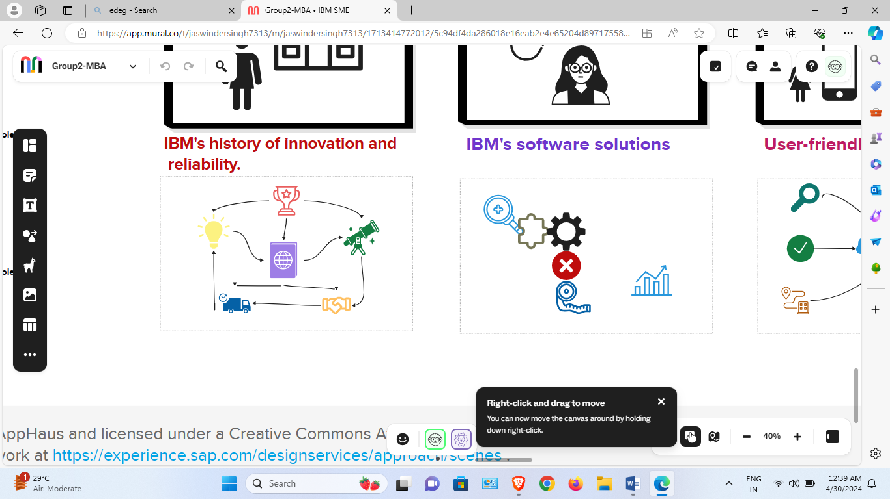

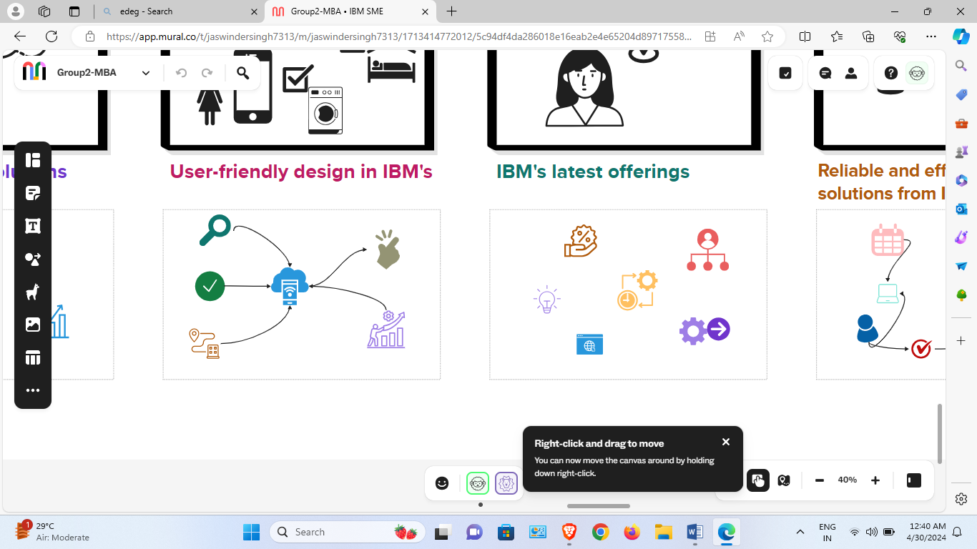

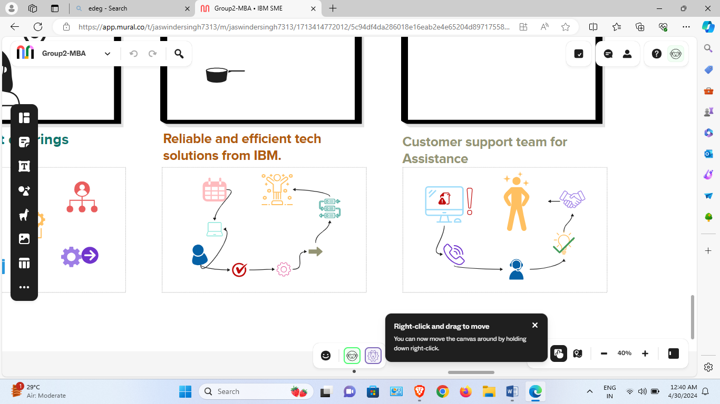

**CRAFTING HILLS**

"Crafting Hills" is a strategic planning approach, it aims to assist organizations in establishing ambitious objectives and then dividing them into achievable tasks. When applied in the context of the MURAL tool, "Crafting Hills" likely involves utilizing MURAL's digital canvas and collaboration features for implementing this strategic planning methodology.

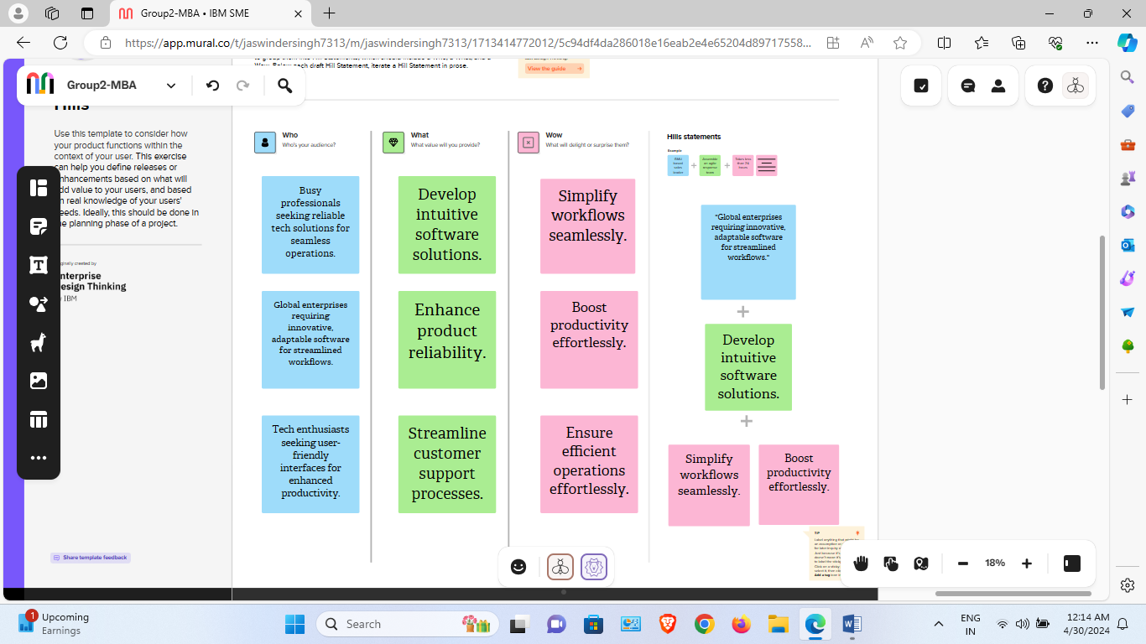



**PRIORITY GRID**

A prioritization matrix is a helpful tool for ranking projects, tasks, or goals. It helps in evaluating and comparing various factors like risks, benefits, costs, and stakeholder concerns.

